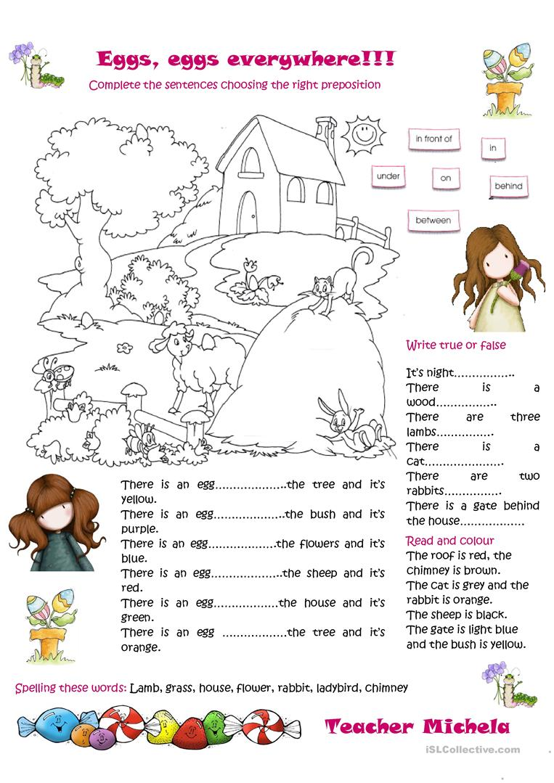

IN
UNDER
BETWEEN
ON
BEHIND
IN FRONT OF

