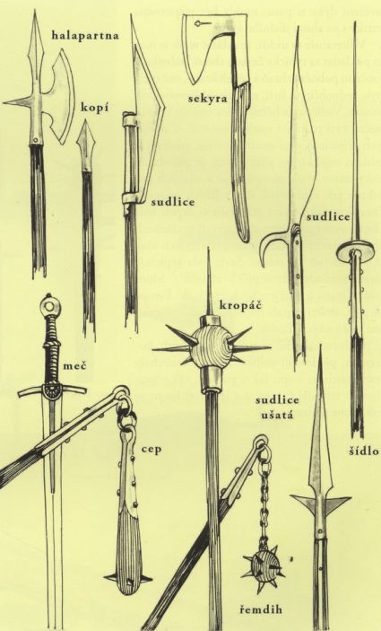

https://www.google.com/search?q=zbran%C4%9B+husit%C5%AF+d%C4%9Bjepis&tbm=isch&ved=2ahUKEwjrwuu8_7foAhWJ0OAKHe3ODaIQ2-cCegQIABAA&oq=zbran%C4%9B+husit%C5%AF+d%C4%9Bjepis&gs_l=img.3...1103093.1109737..1110903...0.0..0.206.1255.11j2j1......0....1..gws-wiz-img.......0i67j0j0i5i30.lHI_dJ_kz6Y&ei=jIx8XuvMHomhgwftnbeQCg&bih=625&biw=1366#imgrc=xW9YJvBCjx7jFM
https://www.google.com/search?q=zbran%C4%9B+husit%C5%AF+d%C4%9Bjepis&tbm=isch&ved=2ahUKEwjrwuu8_7foAhWJ0OAKHe3ODaIQ2-cCegQIABAA&oq=zbran%C4%9B+husit%C5%AF+d%C4%9Bjepis&gs_l=img.3...1103093.1109737..1110903...0.0..0.206.1255.11j2j1......0....1..gws-wiz-img.......0i67j0j0i5i30.lHI_dJ_kz6Y&ei=jIx8XuvMHomhgwftnbeQCg&bih=625&biw=1366#imgrc=pqnFHg1Fn8PwMM&imgdii=PVxDSPRBSb_C6M

