Řeš samostatně příklady.
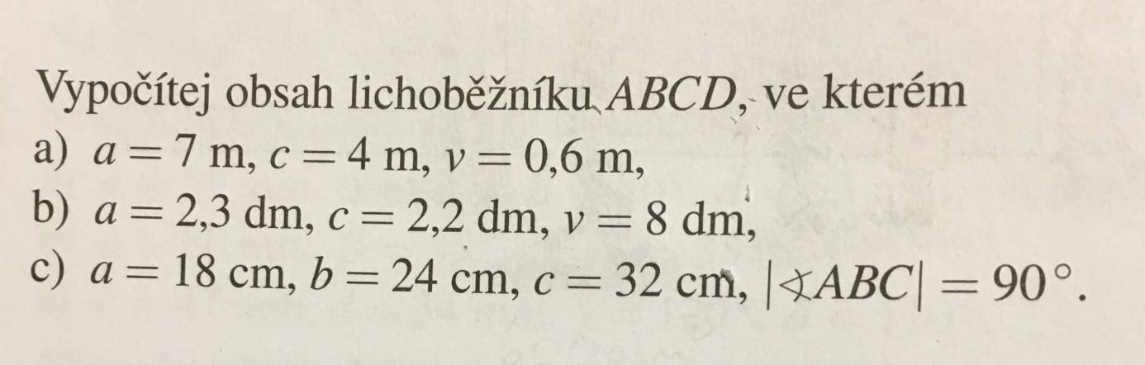

- $S =$ $\frac{\left(a+c\right).v}{2}$ b) S = $\frac{\left(a+c\right).v}{2}$ c) S = $\frac{\left(a+c\right).v}{2}$ b = v = 24 cm

S = $\frac{\left(7+4\right).0,6}{2}$ S = $\frac{\left(2,3+2,2\right).8}{2}$ S = $\frac{\left(18+32\right).24}{2}$

S = 3,3m² S = 18dm² S = 600cm²

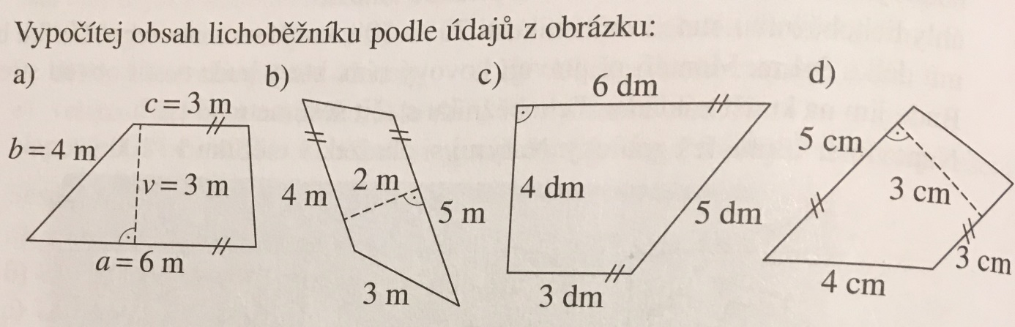
- $S =$ $\frac{\left(a+c\right).v}{2}$ b) $S =$ $\frac{\left(a+c\right).v}{2}$ c) $S =$ $\frac{\left(a+c\right).v}{2}$ d) $S =$ $\frac{\left(a+c\right).v}{2}$
S = $\frac{\left(6+3\right).3}{2}$ S = $\frac{\left(5+4\right).2}{2}$ S = $\frac{\left(6+3\right).4}{2}$ S = $\frac{\left(3+5\right).3}{2}$
S = 13,5m² S = 9m² S = 18dm² S = 12cm²

