Gotika

rozeta | 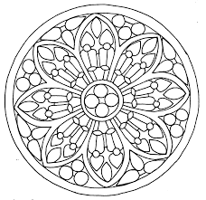
arkýŘ = přístavek na úrovni vyšších pater | 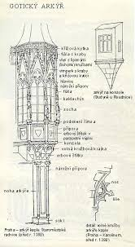
chrliČ = svod dešťové vody | 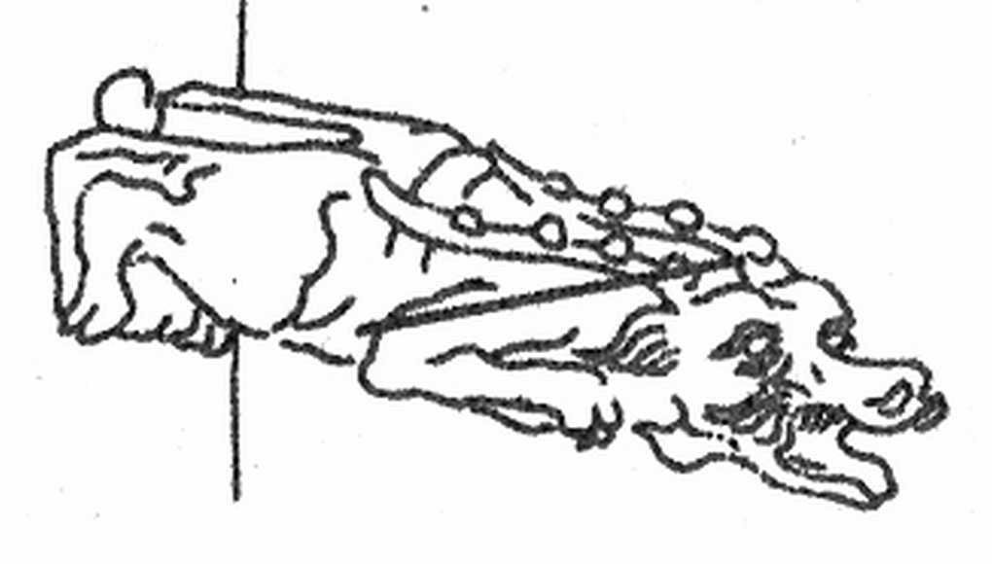
lomený oblouk | 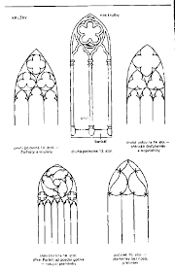
kruŽba = ornamentální prvek užívaný v oknech | 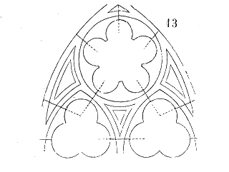
opĚrný systém | 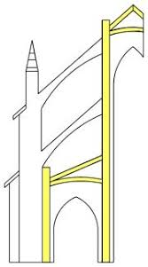

https://www.google.com/search?q=ark%C3%BD%C5%99+gotika&tbm=isch&ved=2ahUKEwi80Oea7bfoAhUP1uAKHcsJA4YQ2-cCegQIABAA&oq=ark%C3%BD%C5%99+gotika&gs_l=img.3..0.44624.47076..47974...0.0..0.92.766.10......0....1..gws-wiz-img.......0i7i30j0i8i7i30j0i67j0i7i5i30.2vUjJFCmEag&ei=ZXl8XvyJEo-sgwfLk4ywCA&bih=625&biw=1366#imgrc=0fIfJ1nJQV3XQM

https://www.google.com/search?q=lomen%C3%BD+oblouk+gotika&tbm=isch&ved=2ahUKEwjKi5Xu7bfoAhVQARQKHWioD5YQ2-cCegQIABAA&oq=lomen%C3%BD+oblouk+gotika&gs_l=img.3..0.69792.73961..74266...0.0..0.123.150 https://www.google.com/search?q=kru%C5%BEba+gotika&tbm=isch&ved=2ahUKEwjNrpyS7rfoAhUL8uAKHeRUAGgQ2-cCegQIABAA&oq=kru%C5%BEba+gotika&gs_l=img.3..0.65107.68534..69275...0.0..1.125.1622.15j4......0....1..gws-wiz-img.......0i7i30j0i67j0i7i5i30j0i8i7i30.LCgAxPjPgmo&ei=X3p8Xo2DLIvkgwfkqYHABg&bih=625&biw=1366#imgrc=6D7S0Tmc2o7Y_M5.18j1......0....1..gws-wiz-img.......0i7i30j0i8i7i30j0i7i10i30j0i67j0i7i5i30j0i8i7i10i30.DCblJJY-K1Q&ei=FHp8XsqxBtCCUOjQvrAJ&bih=625&biw=1366#imgrc=Te1t2JqYEkGp7M
https://www.google.com/search?q=op%C4%9Brn%C3%BD+syst%C3%A9m+gotika&tbm=isch&ved=2ahUKEwiKpZfW7rfoAhWC0uAKHfUmBEQQ2-cCegQIABAA&oq=op%C4%9Brn%C3%BD+syst%C3%A9m+gotika&gs_l=img.3..0j0i5i30l2.9123.13760..14782...0.0..2.168.2130.22j4......0....1..gws-wiz-img.......0i7i30j0i67j0i7i5i30j0i8i7i30.wSnREOnJ1I8&ei=7np8Xor2DoKlgwf1zZCgBA&bih=625&biw=1366

