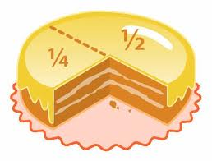**Vypočítej část celku.**

14 =

 64 =

 25 =

 32 =

 18 =

 30 =

 27 =

 14 =

 21 =

 56 =

12 =

24 =

40 =

35 =

25 =